

1. Props in React are short for “properties” and are used to pass data from one component to another, typically from a parent component to a child component. Props are read-only and help in making components reusable by allowing them to accept dynamic inputs.
2. Default props are a mechanism in React to assign default values to props when no value is explicitly provided by the parent component. This helps prevent undefined values and ensures components behave correctly even if some props are omitted.

|  |  |
| --- | --- |
| Props | State |
| Props are used to pass data from parent to child components. | State is used to manage data that changes over time within a component. |
| Props are immutable in the child component. | State is mutable and can be changed using the setState() method. |
| Props are controlled by the parent component. | State is local and controlled by the component itself. |
| Used to pass external data into a component. | Used to store and manage internal component data. |

1. ReactDOM.render() is a method provided by the ReactDOM package to render a React element into the actual DOM in the browser. It takes two arguments which are the React component or element to render, and the DOM node where it should be mounted, typically document.getElementById('root').

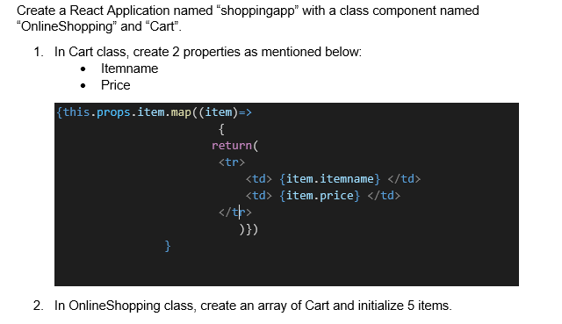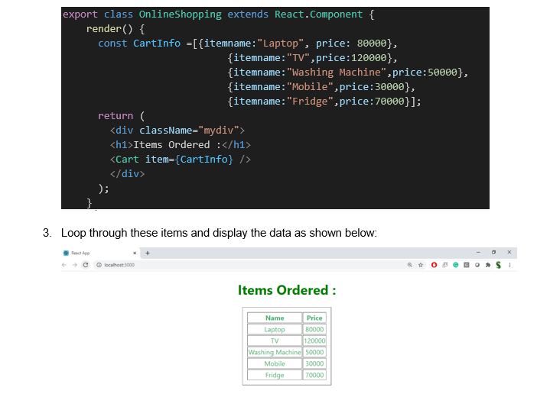

**Solution**

**Cart.js**

import React from 'react';

class Cart extends React.Component {

render() {

return (

<table border="3" style={{ margin: 'auto', width: '50%', textAlign: 'left' }}>

<thead>

<tr>

<th>Name</th>

<th>Price (₹)</th>

</tr>

</thead>

<tbody>

{this.props.item.map((item, index) => (

<tr key={index}>

<td>{item.itemname}</td>

<td>{item.price}</td>

</tr>

))}

</tbody>

</table>

);

}

}

export default Cart;

**OnlineShopping.js**

import React from 'react';

import Cart from './Cart';

class OnlineShopping extends React.Component {

render() {

const CartInfo = [

{ itemname: "Laptop", price: 80000 },

{ itemname: "TV", price: 120000 },

{ itemname: "Washing Machine", price: 50000 },

{ itemname: "Mobile", price: 30000 },

{ itemname: "Fridge", price: 70000 }

];

return (

<div className="mydiv" style={{ textAlign: 'center' }}>

<h1>Items Ordered:</h1>

<Cart item={CartInfo} />

</div>

);

}

}

export default OnlineShopping;

**App.js**

import './App.css';

import OnlineShopping from './OnlineShopping';

function App() {

return (

<div className="App">

<OnlineShopping />

</div>

);

}

export default App;

**Output**

